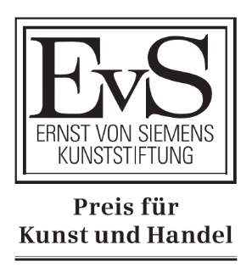
„Project Submission“
Ernst von Siemens Award for Art and Trade

Form for nominating a cooperation project between a museum and an art dealer (auction house, gallery, company, etc.)

author

General information about the cooperation project:

„project titel“:

Participating museum:

Participating retailer/partner/patron:

Object:
(Please send or provide a link to at least one image as a JPG file!)

Significance of the object:
Monetary value of the object:

Alignment with the Award's Goals
Please tick the relevant item(s)
☐ Identification and/or research into a significant work of art by the art trade
☐ Return of a displaced museum object
☐ Patronage-based pricing
☐ Donation/partial donation
☐ Provision of relevant information/research to museums by third parties
☐ International cooperation
☐ Link to TEFAF

Project description

Please outline the key content and goals of the collaborative project (max. 1,500 characters):

Why is this collaborative project worthy of funding (max. 1,500 characters)?
What kind of project (format) could the award help to make possible? (max. 250 characters)
Further comments (max. 1,500 characters):

